Tiwi Pro Portal Data

## Admin Data

Overview

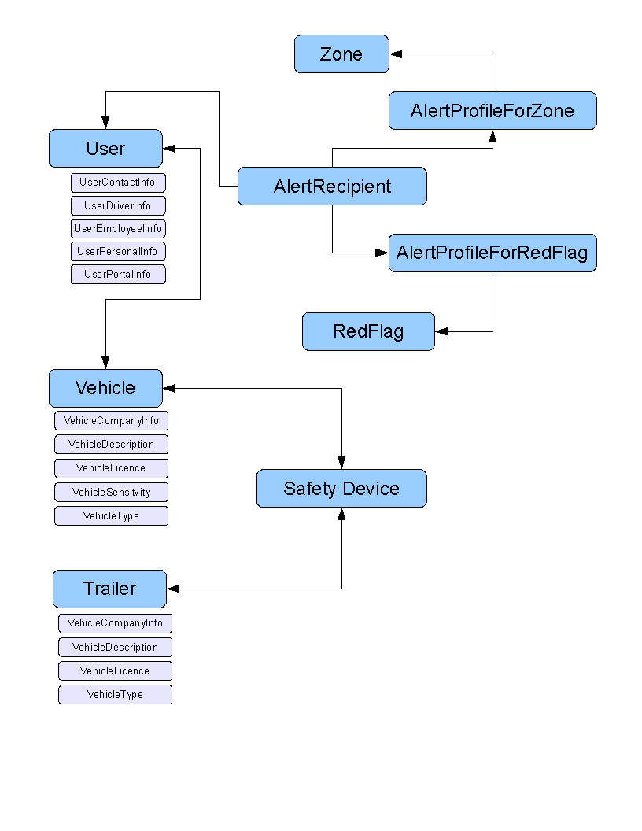

Details

***Address***

String address1;

String address2;

String city;

State state;

String zipCode;

***AlertRedFlagCategory***

int id;

String description;

Int order;

***AlertRedFlagSubCategory***

Int id;

Int catId;

String description;

Int order;

***AlertRedFlag***

Int level; // 1 – information, 2 - warning, 3 – critical

Boolean isAlert;

Int catId;

Int subCatId;

***AlertProfileForRedFlag***

Int id;

String name;

String description;

AlertRedFlag[] drivingRedFlagList;

***AlertProfileForZone***

Int id;

int type; // 1 – enter, 2 – exit, 3 – both

int zoneId;

int driverId; // only one should be set (driverId or vehicleId)

int vehicleId;

int startTimeOfDate // minute of day

int endTimeOfDate // minute of day

Boolean[] dayOfWeek; // list of 7 -- one for each day of week

***AlertRecipient***

Int alertProfileId;

Int userId;

int[] deliveryTypes; // 1 – phone, 2 – email, 3 – sms

***Certification***

int id;

int companyId;

String name;

String decription;

***Company***

int id;

String name;

***DriverLicense***

String number;

String class;

State state;

Date expiration;

***DriverCertification***

int driverId;

int certificationId;

Date expirationId;

***DriverCitation***

Int driverId;

Date dateOfOccurance;

String description;

***Group – Not defined yet***

int id;

***LatLng***

float latitude;

float longitude;

***PhoneNumber***

String number; // 10 digits

String extension; // optional

String countryCode; // ??

Int type; // 1-work,2-home,3-cell,4-other

***RedFlag***

int id;

int userId;

int vehicleId;

LatLng eventLocation;

Date eventTime;

Boolean isAlert;

Int level; // 1 – information

// 2 – warning

// 3 – critical

Int category; // 1 – safety

// 2 – diagnostics

// 3 – driver

// 4 – fuel efficiency

int type;

// corresponds to our current notification type

***Role***

int id;

String name; // Admin, Manager, Super User, Driver

Permission[] permissionList; //?

***SafetyDevice***

Int id;

Int type; // tiwiPro, waySmart, etc

Int assignedVehicleId; // vehicleId assigned to device

String imei;

String deviceIdentification; // name/id defined by company

String smsNumber; // ?? phone number

String firmwareVersion; //??

PhoneNumber eCallNumber; //??

***Trailer***

Int id;

Int companyId;

Int assignedVehicleId;

Group group;

Boolean isActive;

SafetyDevice[] safetyDeviceList;

VehicleCompanyInfo trailerCompanyInfo;

VehicleDescription trailerDescription;

VehicleLicence trailerLicence;

VehicleType trailerType;

***User***

int id;

int companyId;

Group group;

int timezone;

int units; // ENGLISH = 0; METRIC = 1

Boolean isActive;

UserContactInfo contactInfo;

UserDriverInfo driverInfo;

UserEmployeeInfo employeeInfo;

UserPersonalInfo personalInfo;

UserPortalInfo accessInfo;

***UserContactInfo***

Int userId;

String emailAddress;

String smsAddress; // for text messages

PhoneNumber[] phoneNumberList; // home, work, cell, etc.

***UserDriverInfo***

int userId;

DriversLicence license;

int dot; // 0 – non-dot, 1 – x Default Rule set Id

DriverCertification[] certificationsList;

Int points;

DriverCitation[] citationList;

***UserEmployeeInfo***

Int userId;

String employeeIdentification; // name/id defined by company

String title;

String department;

String reportsTo;

int costPerHour; // in cents ???

***UserPersonalInfo***

Int userId;

String firstName;

String lastName;

String middleName;

String suffix;

Date dob;

Address address;

int gender; // 0 – unknown, 1 – male, 2 - female

int height; // inches

int weight; // pounds

***UserPortalInfo***

Int userId;

String userName;

String password; // same encryption as Teen Portal

Role role;

***Vehicle***

int id;

int companyId;

int assignedDriverId;

int startOdometer;

int timezone;

boolean isActive;

SafetyDevice[] safetyDeviceList;

VehicleCompanyInfo companyInfo;

VehicleDescription description;

VehicleLicense license;

VehicleSensitivity sensitivity;

VehicleType vehicleType;

***VehicleCompanyInfo***

int vehicleId;

String vehicleIdentification; // name/id used by company

int costPerHour; // in cents

***VehicleDescription***

int vehicleId;

String make;

String model;

String year;

String color;

int weight; // pounds

String VIN; // 17 chars

***VehicleLicense***

int vehicleId;

String number;

State state;

***VehicleSensitivity***

int vehicleId;

int hardAccelerationLevel;

int hardBrakeLevel;

int hardTurnLevel;

int hardVerticalLevel;

***VehicleType***

int id;

String description; // e.g. sedan, suv, etc

***Zone***

int id;

int companyId;

Group group; // ??

String name;

Address address;

int type; // 0 – polygon, 1 – circle, 2 - rect

LatLng points[];

## Report Data

Overview